**Chapter-5 (Practice Questions Lecture-18 )**

1. Determine the input conditions needed to cause the output in figure to go to its active state.

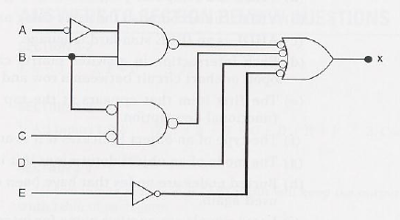

1. The circuit figure is supposed to be a simple digital combination lock whose output will generate an active –LOW signal for only one combination of inputs. Modify the circuit diagram so that it represents more effectively the circuit operation. Also modify the circuit for active HIGH. Writdown the statements for both( active HIGH and LOW output).

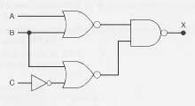

1. Simplify the expression for the output of the figure. Also draw the circuits diagram for simplified expression.

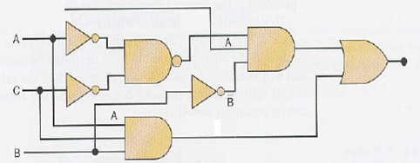

1. Write the output expression for each circuit as it appears in Figure and then change each circuit to an equivalent AND-OR configuration.

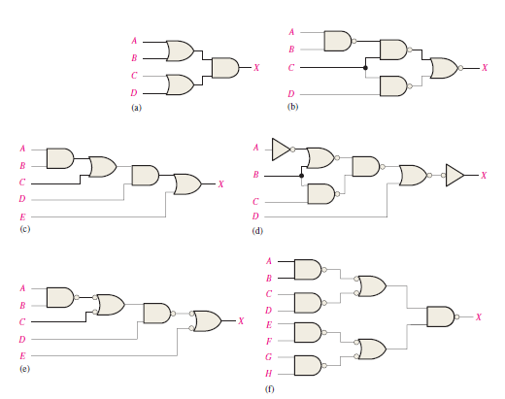

1. Simplify the circuit in Figure as much as possible, and verify that the simplified circuit is equivalent to the original by showing that the truth tables are identical.

